Name:
Course:
Tutor:
Date:
Mental Map
The following mental map represents my neighborhood in Queens Area, New York.
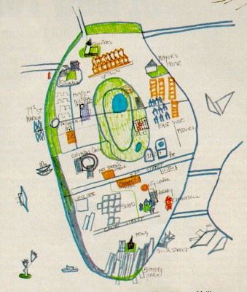
To me the most important features that should be found within a mapped area are the grids, the symbols and scale. These important elements contain the scale of the map to illustrate and represent models of reality. It is evident that a map scale is used to indicate and show the relationship that exists between two distances within a mapped area. These indicate the relationship that help to prove the distances between actual areas. They show the actual representation of the map within a grid. The other core elements that show actual representation of a mapped area include the main body, the title of the map, the legend, the orientation, the scale and the source notes. These are necessary in demonstrating how different elements and regions within a map are illustrated. In essence, the other key features that show the representation of a mapped area includes the conventional signs, the directions, map projection and the key. These illustrate the importance of a mapped area (Harder & Brown, 2017).
The map is used to show important elements about my life. For instance, the map can be used to show where I schooled, key features of the sea within New York area and the community. These are the neighborhoods where I grew as a child. The mapped region has been essential in demonstrating that an individual can be born in this region and still live a good and normal life. This is the actual area where I have previously lived as a child. The main form of transport that I have used were the roads and also the sea. I would travel through the sea when I was in holidays while I would travel by the roads as indicated in the map.
Works Cited
Harder, C., & Brown, C. (2017). The ArcGIS book: 10 big ideas about applying the science of where. Redlands, California

